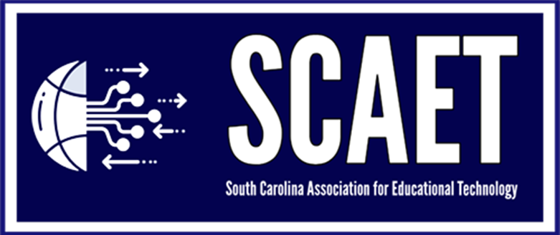
2025 SC EdTech Esports Tournament
Parent Student Media Consent Form

I understand my child may be photographed, videotaped and/or voice recorded during the Esports Tournament. His/her name, image, likeness, and voice may be used in SCAET approved photographs, videos, publications, internet, news, social media, and web pages.

I understand that my child will be supervised by his/her school supervisor during the tournament. My child has the right to refuse to answer any questions or participate in any discussions that make him/her feel uncomfortable or embarrassed. Additionally, my child or supervising school coach has the right to terminate photo or video sessions at any time for any reason.

I understand that SCAET or anyone broadcasting the event has any obligation to air or publish the images, photos, videotape and /or voice of my child.

I also understand that neither I nor my child will receive any monetary compensation for the rights granted herein. I also understand that my child’s appearance or the use of his/her voice in any publication, photo, internet, or televised form does not confer any ownership rights to me or my child.

I hereby unconditionally release SCAET and its representatives from all claims/demands arising out of the activities under the terms of this agreement.

*Required information
- Student First and Last Name*: ______________________________________________________________________________
- Student Mailing Address*: ____________________________________________________________________________________________________________________________________________________________
- Name of Student’s School*: ______________________________________________________________________________
- Name of Parent/Legal Guardian*: ______________________________________________________________________________
- Parent Email Address*: ______________________________________________________________________________
- Please select one option below. *:
- I agree with the SCAET media release terms and conditions. By signing this form, I agree to the above terms and conditions of the media release.
- I disagree with the SCAET media release terms and conditions. By signing this form, my child MAY NOT be photographed, videotaped, or used on social media/webpages for this event. I understand that he/she will not appear in the photographs if their team wins or on any broadcast of the event.

- Please sign parent/legal guardian below as agreement*.
Parent/Legal Guardian Signature*: ___________________________________________
8. Date of Agreement: * ________________________________

*** Completed form must be returned to SCAET by October 17, 2025 in order for student
to attend the EdTech 2025 Esports Tournament.
Email to jcassidy@scaet.org. ***

